January 15, 2021
Happy Dr. King Weekend! Join me in being thankful for the great work and accomplishments of Dr. Martin Luther King, Jr. Although his passing was over 50 years ago, his legacy is alive and well today. Our teachers still teach the students about his life, his leadership, and his mission to unite all people. His dynamic influence on the civil rights movement is yet remembered. Click HERE to view a resource released by the US Department of Education that may give you suggestions of how your family can honor and observe Dr. King’s National Day.

Return of Students Updates
A portion of our students have returned to the building as of Monday. All is going smoothly! We are still maintaining safety precautions by wearing masks, keeping social distancing guidelines, and minimizing transitions. On Thursday, we practiced a fire drill in the afternoon. Our noon aides have returned to monitor lunch in the classroom, and Sunview welcomed a new permanent building substitute, Ms. Petti.
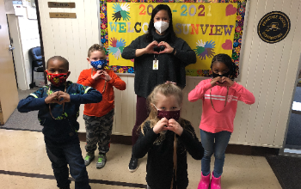
3rd Quarter Declarations
Thank you for your timely 3rd quarter declaration responses! We will be receiving approximately 30 more students on campus starting Feb. 1st. We will still maintain our commitment of safety in the classrooms. For students already in-person, there may be minor changes to your child’s class location and/or structure in order to accommodate extra students. If this is the case for your child, more details will be provided next week. For those who are switching from remote to in-person learning, specific emails will be forthcoming.
Dates to Remember
Jan 18 – Observance of Dr. King Day
Jan 29 – No School – Teacher Work Day

